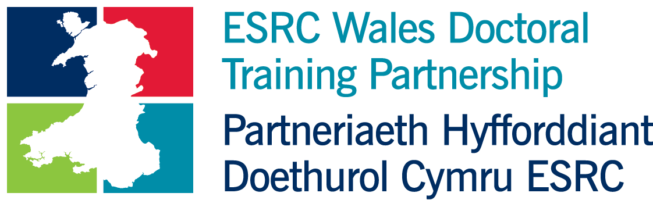

Methods for Critical Social Science, 27th-28th April 2022
Wednesday 27th April 2022
9:30am-9:45am | Welcome and Opening Remarks  Professor John Harrington, ESRC Wales DTP Director  Judge Ray Singh CBE, Chair, Race Council Cymru
9:45am-10:30am | Keynote Lecture  Picking Your Way Across the Qualitative Research Landscape; learning to avoid the bumps while not missing the beauty  Professor Sara Ryan, Manchester Metropolitan University  followed by Q&A
11:30am-12:30pm: | Workshop I: Race and Masculinities  Using third objects when conducting qualitative research  Dr Constantino Dumangane Jr, University of York  with breakout and group discussion
1:30pm-2:30pm: | Workshop II: Data-Based Research on Inequalities  The HAPPEN Wales Primary School Network: Bridging the gap between health and education  Dr Emily Marchant, Wales DTP Postdoctoral Fellow  Trusted Research Environments (TRE) support for PhD projects  Jon Smart, Administrative Data Research (ADR) UK  followed by Q&A
4:00pm-5:00pm: | Student Forum I: Qualitative Methods  Feminist narrative: Black mothers’ experience of imprisonment  Monica Thomas, Wales DTP student, Cardiff University  Participatory action research: Experts by Experience in food security governance  Barbara Adlerová, Wales DTP student, Cardiff University  Linguistic analysis of victim accounts: Online grooming communication  Ruth Mullineux, Wales DTP student, Swansea University  Photography in Wales: gender and Nationhood  Eve Ruet, Wales DTP student, Cardiff University  with breakout and group discussion
TIME | Thursday 28th April 2022
9:30am-10:30am: | Workshop III: Achieving Social Impact  Legally Disabled?: The Career Experiences of Disabled people in the Legal Profession in England & Wales  Professor Deborah Foster, Cardiff University  Co-production in Practice: Disability Research  Ruth Nortey, Wales DTP student, Cardiff University  Reflections on being a partner in co-producing findings, recommendations and impact  Jane Burton, Chair, Lawyers with Disabilities Division of The Law Society  followed by Q&A
11:00am-12:00pm: | Student Forum II: Quantitative Methods  Mixing qualitative and quantitative methods: enhancing equality for deaf athletes  Libby Steele, Wales DTP student, Bangor University  Investigating the gender pay gap in Medicine in the UK  Julia Diniz, Wales DTP student, Cardiff University  with breakout and group discussion
12:15pm-13:15pm | Townhall Meeting: An Equality, Diversity and Inclusion Strategy for the DTP  Introductory briefing from Professor John Harrington, Wales DTP Director  Themed small group and plenary discussions on current issues, steps to widen participation, improve experience, widen research focus.  Facilitated by members of DTP team, Wales DTP EDI committee.

